**EXP NO: 06**

**DATE: 14-04-24**

**Aim:**

Create a simple cloud software application for Payroll Processing System using any Cloud Service Provider to demonstrate SaaS include the necessary fields such as Name of the employee, experience in present org, over all experience, basic pay, HRA, DA, TA, net pay, gross pay etc.

**Implementation:**

**1. Go to Zoho.com and login/signup**

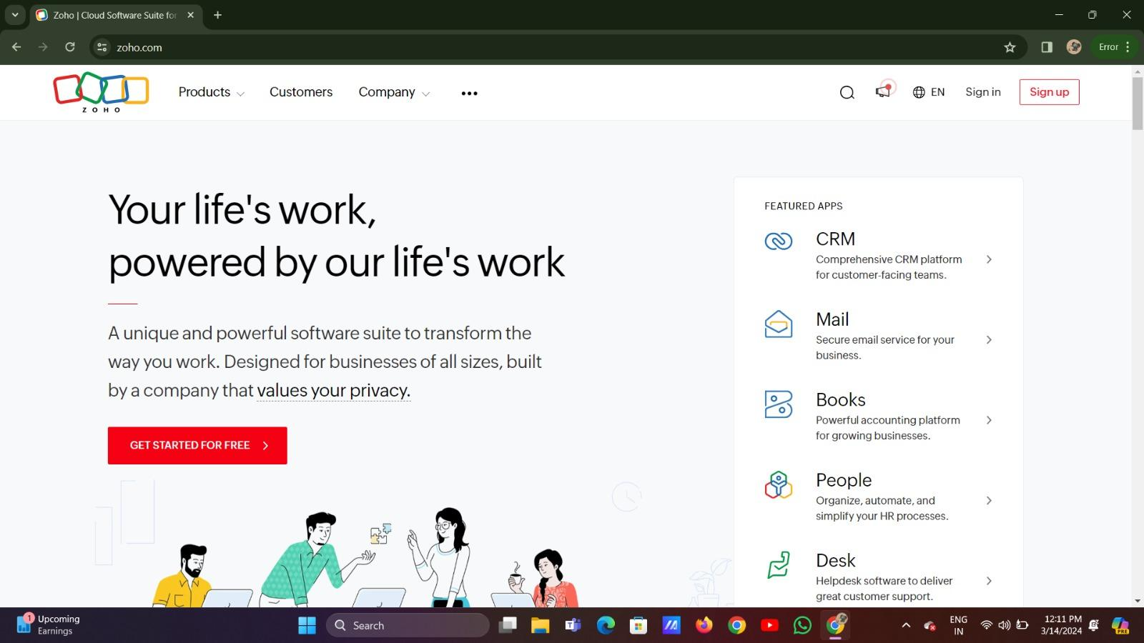

**2. Go to Creator**

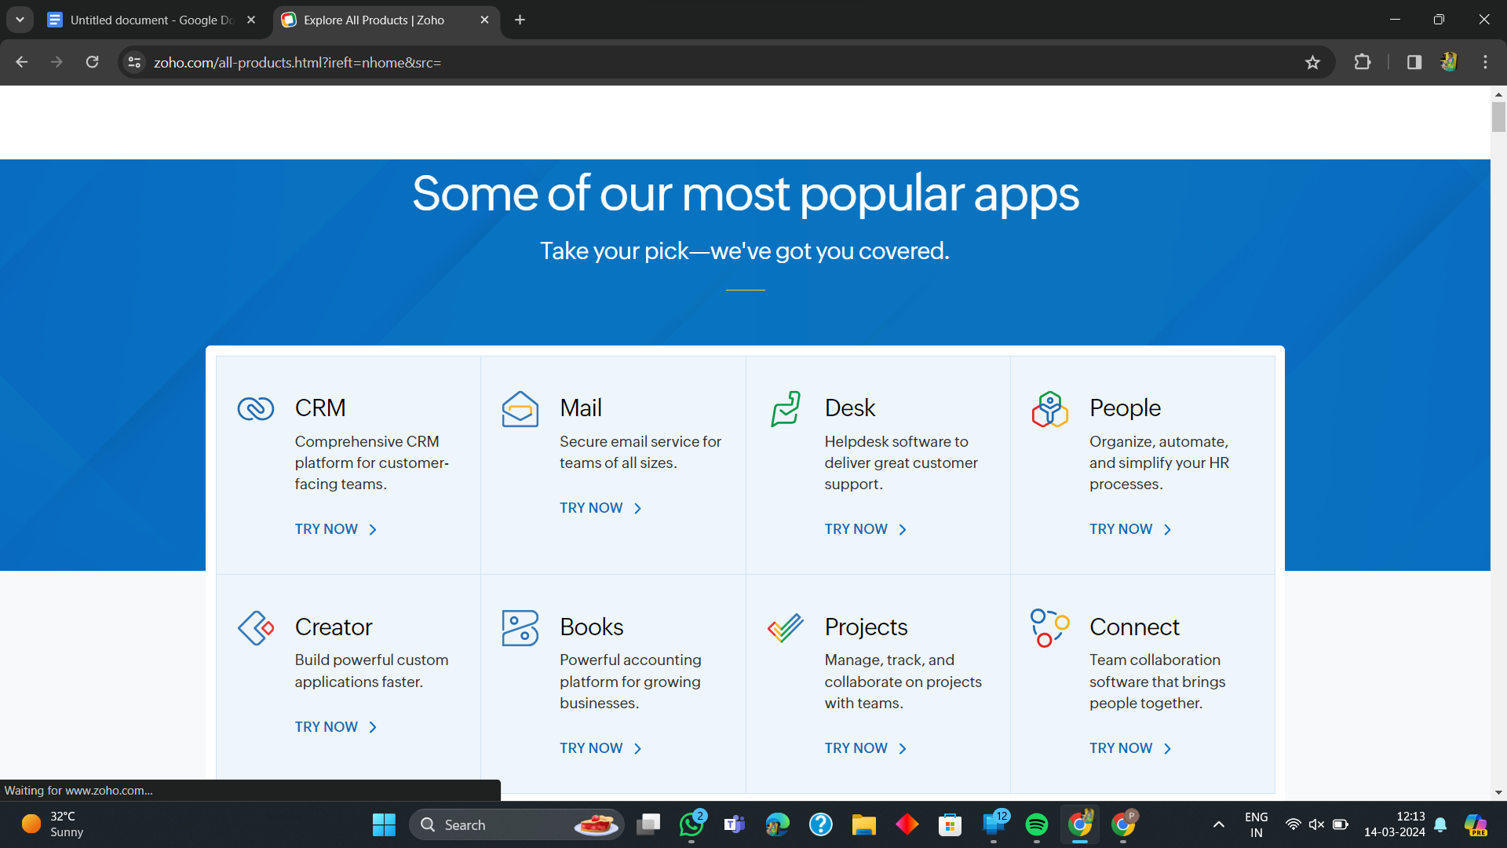

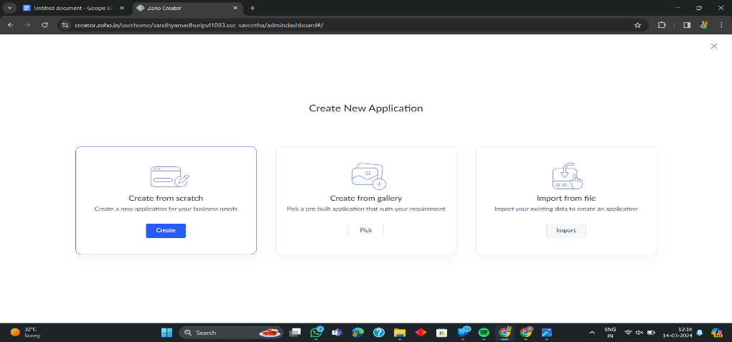**3. Create A New Application**

**4. Given Application Name**

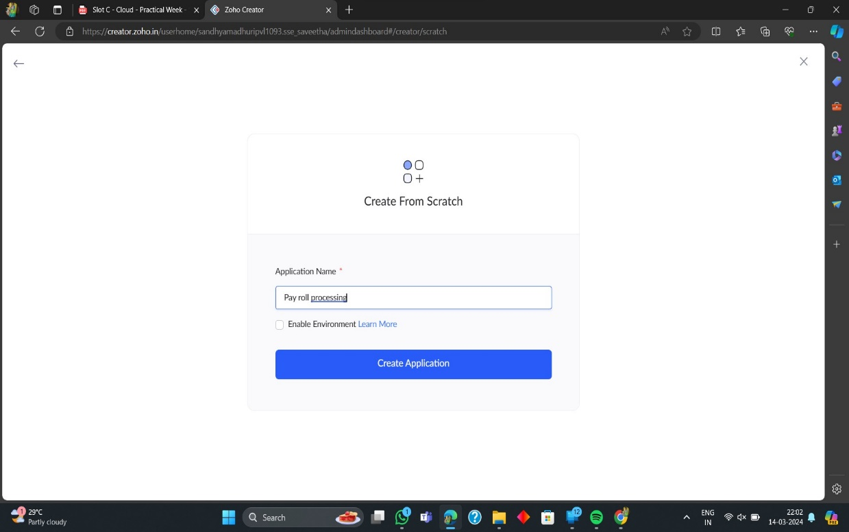

**6. Select Form and Give Name**

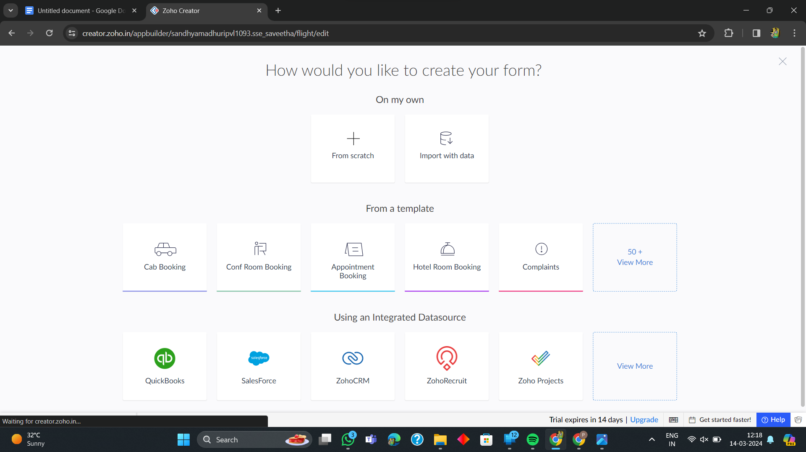

**7. Create from scratch**

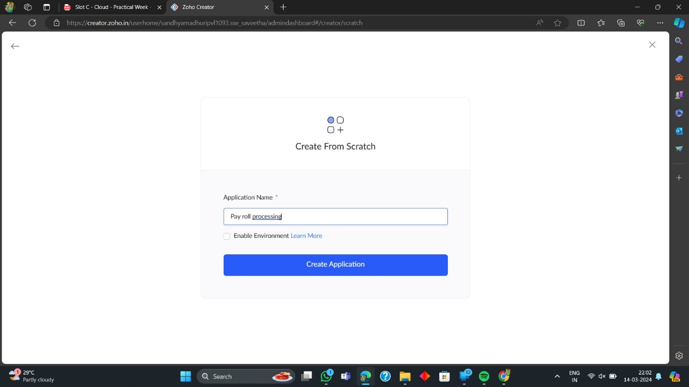

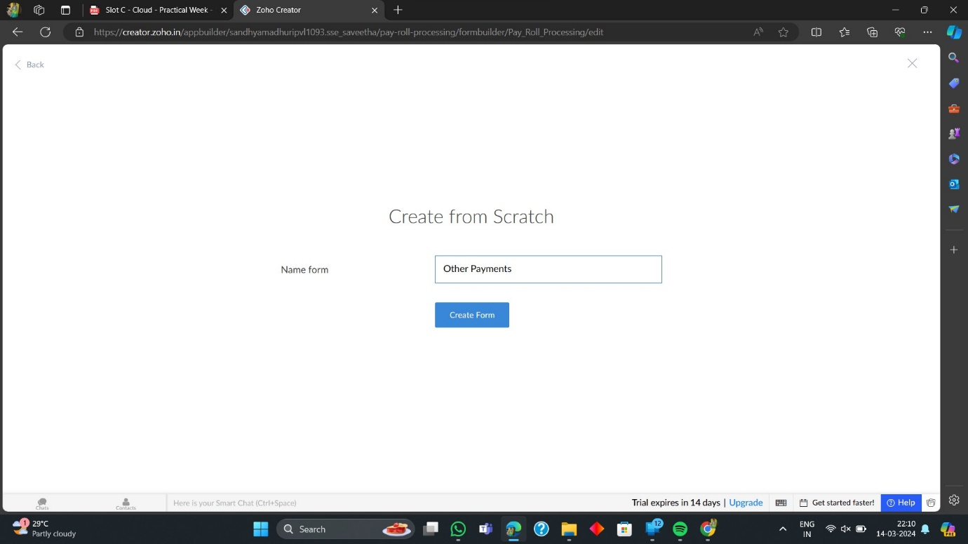

**8. The Software Has been created**

